# MOKSHI AYA FYCS - 04

**Questions on ER diagram**

# PRACTICAL NO. 4

1. Construct an E-R diagram for a car-insurance company whose customers own one or more cars each. Each car has associated with it zero to any number of recorded accidents.

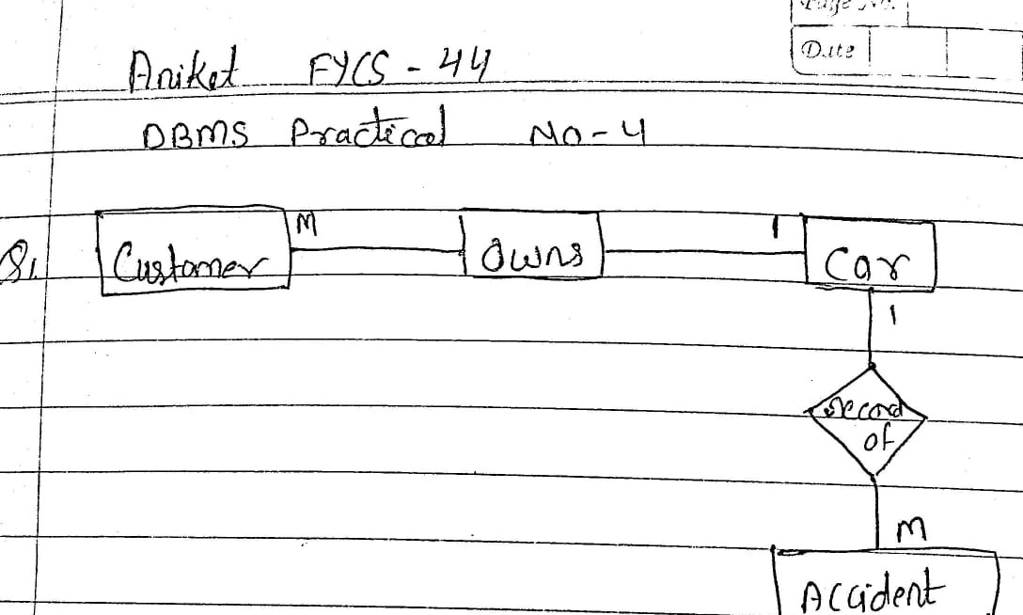

1. Construct an E-R diagram for a hospital with a set of patients and a set of medical doctors. Associate with each patient a log of the various tests and examinations conducted.

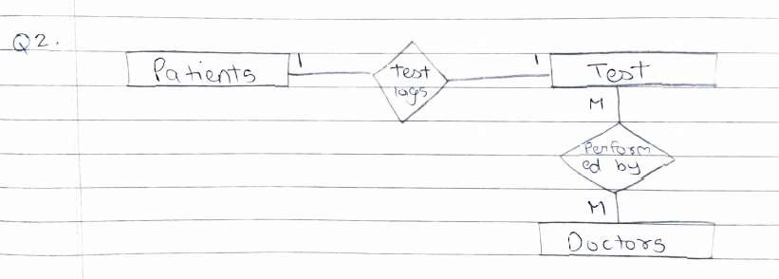

1. A university registrar.s of_ce maintains data about the following entities: (a)courses, including number, title, credits, syllabus, and prerequisites; (b) course offerings, including course number, year, semester, section number, instructor(s), timings, and classroom; (c) students, including student-id, name, and program; and (d) instructors, including identi-cation number, name, department, and title.

Further, the enrollment of students in courses and grades awarded to students in each course they are enrolled for must be appropriately modeled.

Construct an E-R diagram for the registrar.s of_ce.Document all assumptions that you make about the mapping constraints.

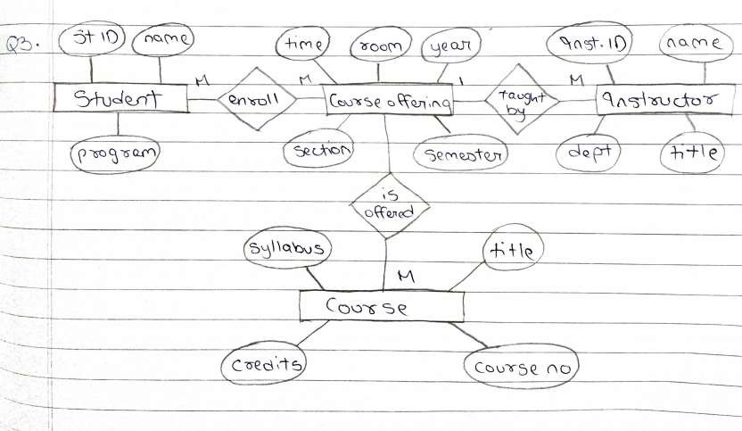

1. Draw the ER diagram for the given scenario
   * In an educational institute, there are several departments and students belong to one of them. Each department has a unique department number, a unique name, a location, a phone number and is headed by a professor.
   * Professors have a unique employee id, name, phoneno. We like to keep track of the following details regarding students: name, unique roll no, gender, phone number, date of birth, age and one or more email addresses.
   * Students have a local address consisting of the hostel name and the room number. They also have home address consisting of house number, street, city and pin. It is assumed that all students reside in the hostels.
   * A course taught in a semester of the year is called a section. There can be several sections of the same course in a semester; these are identified by the section number. Each section is taught by a different professor and has its own timings and a room to meet.
   * Students enroll for several sections in a semester. Each course has a name, number of credits and the department that offers it. A course may have other courses as pre- requisites i.e courses to be completed before it can be enrolled in.
   * Professors also undertake research projects. These are sponsored by funding agencies and have a specific start date, end date and amount of money given. More than one professor can be involved in a project. Also a professor may be simultaneously working on several projects. A project has a unique projectid.

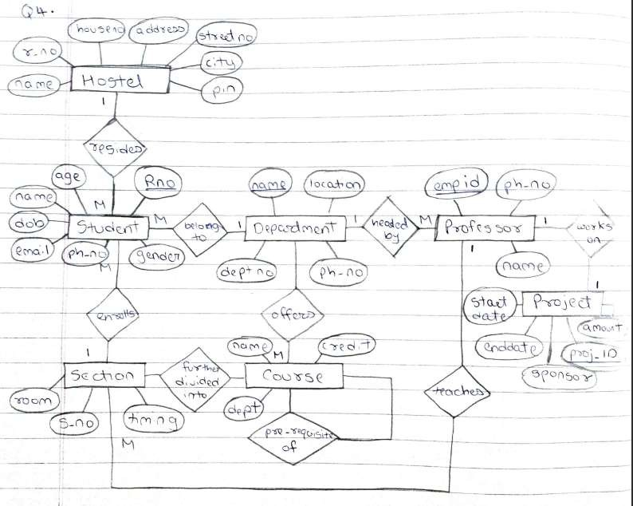

1. Draw the ER diagram for the given scenario.

“A football club has a name and a ground and is made up of players. A player can play for only one club and a manager, represented by his name manages a club. A footballer has a registration number, name and age. A club manager also buys players. Each club plays against each other club in the league and matches have a date, venue and score.

